**Practical -9**

**Introduction To Java Script**

1. Write an HTML which contains Java Script in the head section, which calculates percentage from the five subject marks. Display all five subject marks and percentage on the web page.:

<html>

<head>

<meta charset="UTF-8" />

<meta name="viewport" content="width=device-width, initial-scale=1.0" />

<title>Document</title>

<script>

var1 = parseInt(prompt("Enter marks 1 : "));

var2 = parseInt(prompt("Enter marks 2 : "));

var3 = parseInt(prompt("Enter marks 3 : "));

var4 = parseInt(prompt("Enter marks 4 : "));

var5 = parseInt(prompt("Enter marks 5 : "));

per = (var1 + var2 + var3 + var4 + var5) / 5;

document.write("sub1 marks is : " + var1 + "<br>");

document.write("sub2 marks is : " + var2 + "<br>");

document.write("sub3 marks is : " + var3 + "<br>");

document.write("sub4 marks is : " + var4 + "<br>");

document.write("sub5 marks is : " + var5 + "<br>");

document.write("TOTAL PERCENTAGE IS : " + per + "<br>");

</script>

</head>

<body></body>

</html>

**OUTPUT :-**

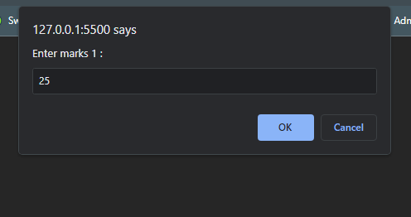

1. Write a Java Script which displays all the even numbers from 1 to 100. hint syntax of for loop :

for(initialize ; condition ; increment)

<html>

<head>

<title>Document</title>

<script>

for(i=1;i<=100; i++){

if(i%2==0){

document.write(i + "<br>" );

} }

</script>

</head>

<body>

</body>

</html>

**OUTPUT :-**

3. Write a Java Script to check whether the number is prime or not.

<!DOCTYPE html>

<html lang="en">

<head>

<meta charset="UTF-8">

<meta name="viewport" content="width=device-width, initial-scale=1.0">

<title>Document</title>

<script>

let flag =0;

var1 = parseInt(prompt("Enter the no : "));

for(i=1 ; i<=var1 ; i++){

if(var1%i==0){

flag= flag+1;

}

}

if(flag>2){

document.write(var1 + " is not a prime No ");

}

else{

document.write(var1 + " is a prime No ");

}

</script>

</head>

<body>

</body>

</html>

***OUTPUT*** *:-*

1. Write a Java Script to check whether the last digit of three numbers is same or not

<html>

<head>

<meta charset="UTF-8">

<meta name="viewport" content="width=device-width, initial-scale=1.0">

<title>Document</title>

<script>

var1 = parseInt(prompt("Enter no 1 : "));

var2 = parseInt(prompt("Enter no 2 : "));

var3 = parseInt(prompt("Enter no 3 : "));

if(var1 %10 == var2%10 && var2%10 == var3%10){

document.write("the No of last three digits is same the digit is = " + var1);

}

else{

document.write("the No of last three digits is Not same ");

}

</script>

</head>

<body>

</body>

</html>

**OUTPUT :-**

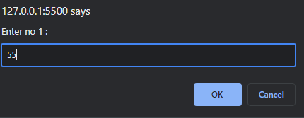

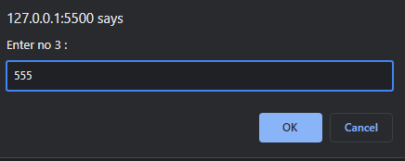

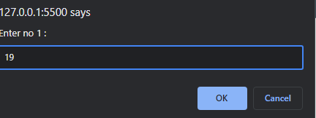

5. Write a Java Script which takes username and password using prompt box. If the username and password are “Admin” then it will display “Successful Login” message in the alert box otherwise it will display “Username and Password are not matched” message in the alert box.

<!DOCTYPE html>

<html lang="en">

<head>

<meta charset="UTF-8">

<meta name="viewport" content="width=device-width, initial-scale=1.0">

<title>Document</title>

<script>

username = prompt("Enter the username ");

pass = prompt("Enter the password ");

if(username== "Admin" && pass=="Admin"){

alert("successful login");

}

else{

alert("“Username and Password are not matched");

}

</script>

</head>

<body></body>

</html>

**OUTPUT :-**

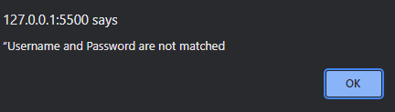

6. Write a Java Script which contains functions to calculate area of circle, rectangle and triangle. Write a switch case to call above functions and take choice number from the user using prompt box.

<!DOCTYPE html>

<html lang="en">

<head>

<meta charset="UTF-8">

<meta name="viewport" content="width=device-width, initial-scale=1.0">

<title>Document</title>

<script>

function area_of_circle() {

var1 = parseInt(prompt("Enter the radius :"));

formula = (22/7)*var1*var1;

document.write("the area of circle of " + var1 +" is "+ formula );

}

function area_of_tri(){

let b = parseInt(prompt("Enter the base :"));

let h = parseInt(prompt("Enter the height :"));

formula = 0.5*b*h;

document.write("the area of triangle is "+ formula );

}

function area_of_rec(){

let w = parseInt(prompt("Enter the width :"));

let h = parseInt(prompt("Enter the height :"));

formula = w*h;

document.write("the area of rectangle is "+ formula );

}

ans = parseInt(prompt("1. for Area of Circle\n2. for area of rectangle\n 3. from area of triangle"));

switch (ans) {

case 1: area_of_circle();

break;

case 2: area_of_tri();

break;

case 3: area_of_rec();

break;

default: prompt("Enter a valid no ");

break;

}

</script>

</head>

<body>

</body>

</html>

**OUTPUT :-**

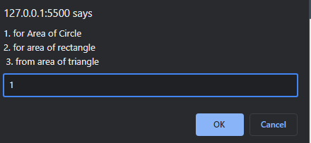

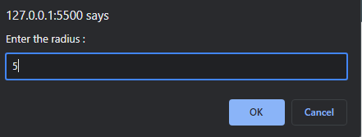

7. Create login form. When user clicks on login button it will display following messages. a. If password is empty “Please enter Password” b. If username is empty “Please enter Username” c. If both username and password are „Admin‟ then “Login successful” d. If both username and password are not matched then “Login unsuccessful” e. If username is not „Admin‟ then “Enter correct Username” f. If password is not „Admin‟ then “Enter correct Password”

<!DOCTYPE html>

<html lang="en">

<head>

<meta charset="UTF-8">

<meta name="viewport" content="width=device-width, initial-scale=1.0">

<title>Document</title>

</head>

<body>

<form action="" onsubmit="return validate()" name="form">

<input type="text" name="usernmae" id="username">

<input type="password" name="password" id="password">

<input type="submit" value="Submit">

</form>

</body>

</html>

<script>

function validate(){

var username = document.forms["form"]["username"].value;

var password = document.forms["form"]["password"].value;

if(username=="")

{

alert("Enter username");

}

else if(password==" ")

{

alert("Enter password");

}

else{

if (username == "Admin") {

if (password == "Admin") {

alert("Successful Login");

}

else {

alert("Enter Correct Password");

}

}

else {

alert("Enter Correct Username");

}

}

}

</script>

**OUTPUT :-**

